Module 7: Functions and Script Organization

Dat Phan
University of Advancing Technology
NTS370: Shell Scripting for Technologists
Dr. Briant Becote
June 1, 2025

Creating and Using Functions
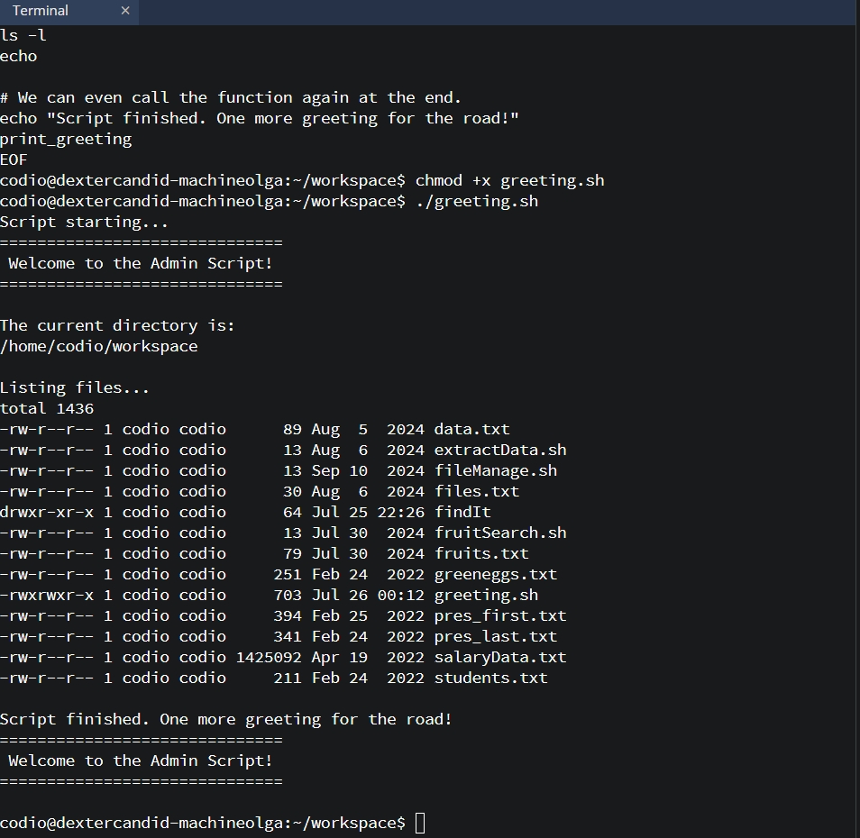
Passing Arguments to Functions
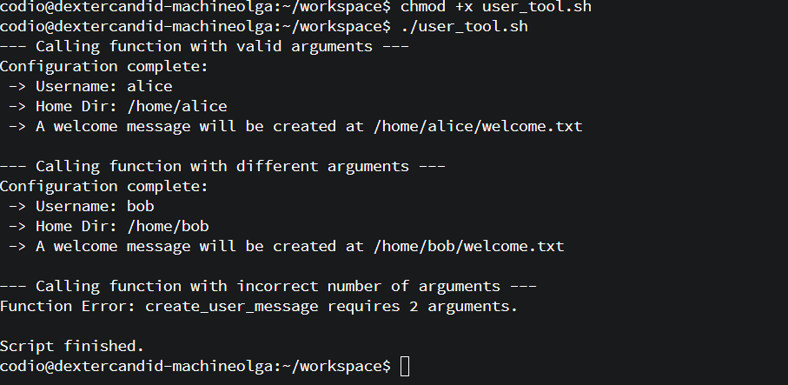
Variable Scope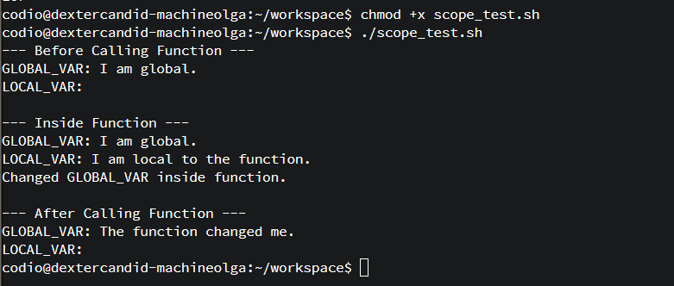

Returning Values from Functions
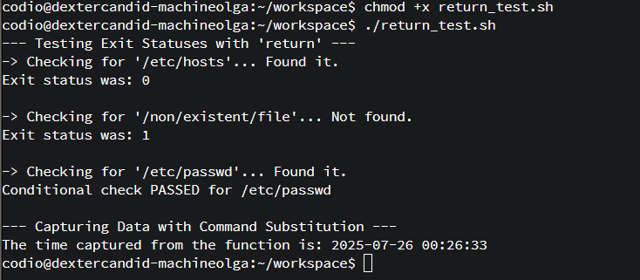

Script Libraries and Sourcing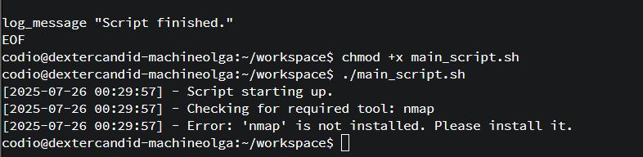

Global Scope: The Default Behavior
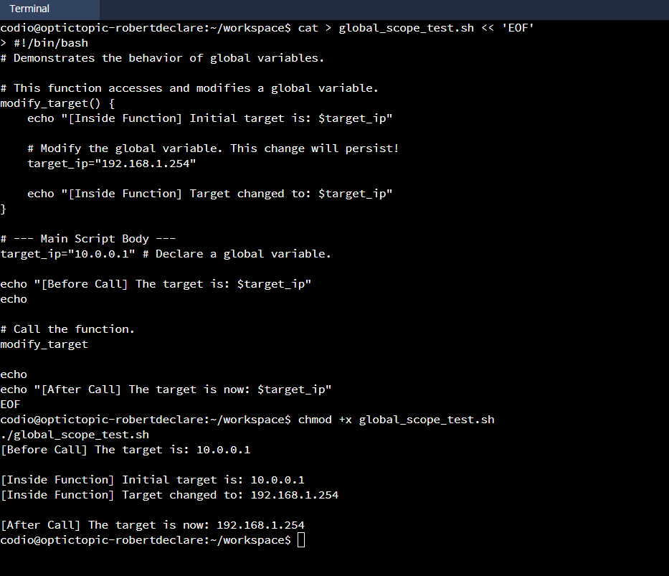

Local Scope: Protecting Your Variables
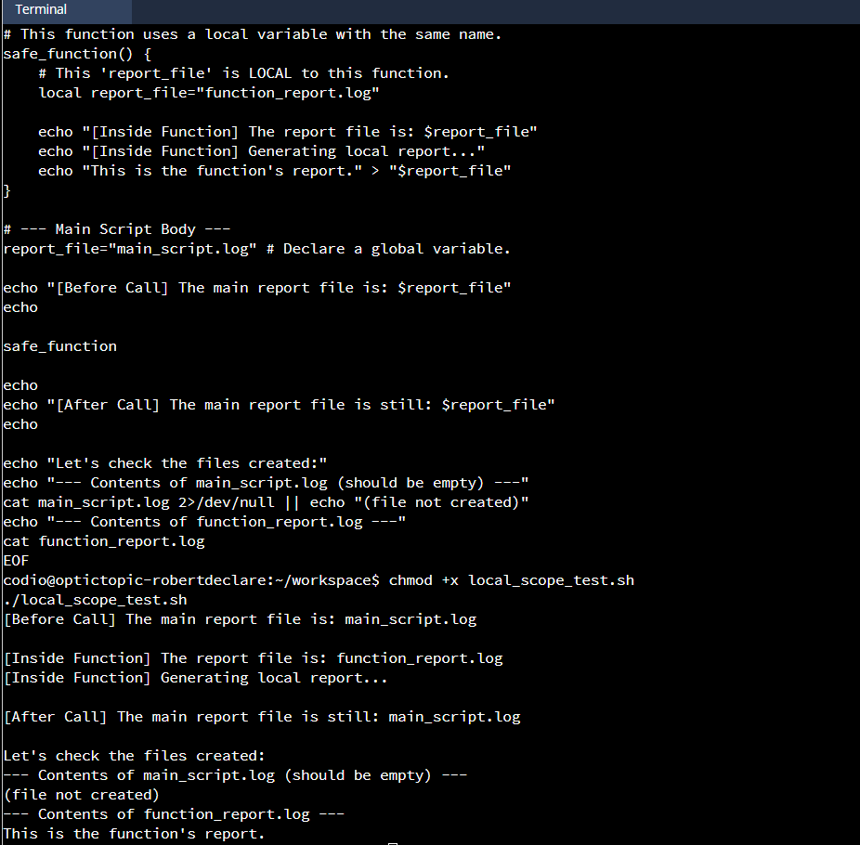

Building and Using a Library

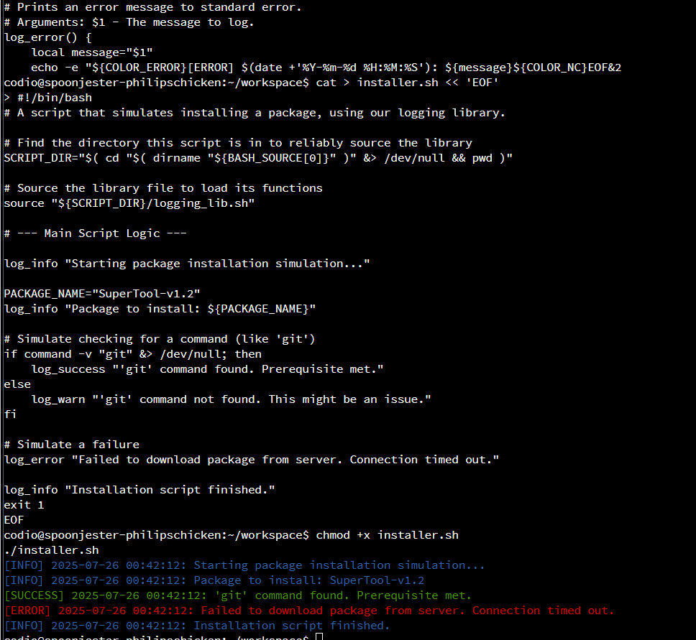

Creating a Script with a Header

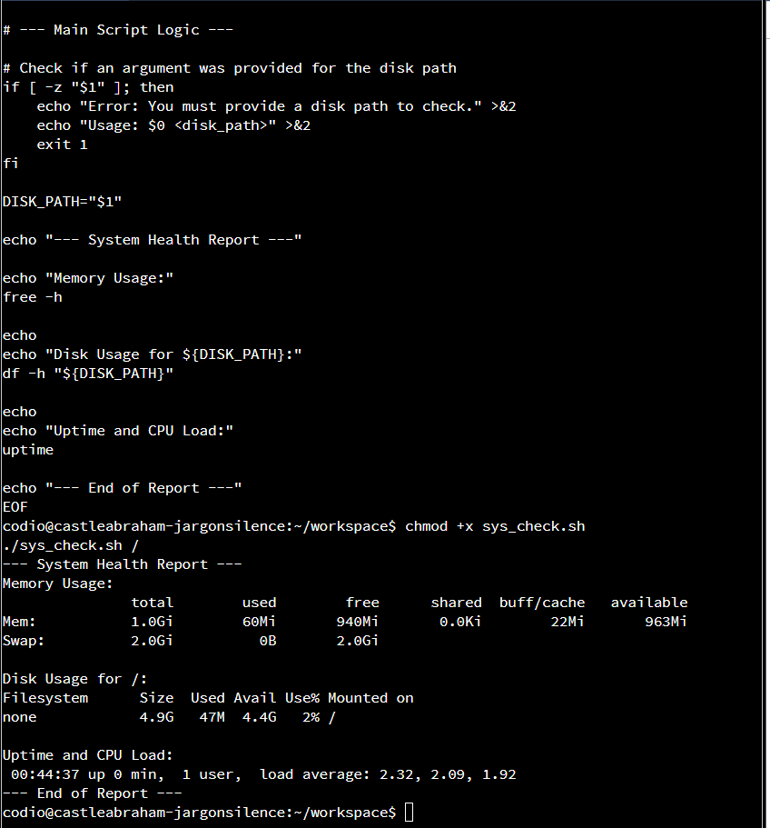

Implementing a usage Function


